WEEK 5 –ReactJS-HOL

Submitted By: Priyanshu Shekhar
Superset ID: 8011160
College: C. V. Raman Global University, Odisha
Registration No.: 2301020267
Email: shekharpriyanshu21@gmail.com

Question 1: Introduction to React & Creating First App

Code:
import logo from './logo.svg'; import './App.css';

function App() { return (
<h1>Welcome the First Session of React</h1>
);
}
export default App;

Output:


Question 2: Class Components in React

Code:

//About.js
import React, { Component } from 'react'; class About extends Component {
render() {
return (
<div>
<h3>Welcome to the About page of Student Mangement Portal </h3>
</div>
);
}
}
export default About;

//Contact.js
import React, { Component } from 'react'; class Contact extends Component {
render() {
return (
<div>
<h3>Welcome to Contact page of Student Mangement Portal</h3>
</div>
);
}
}export default Contact;

//Home.js
import React, { Component } from 'react'; class Home extends Component {
render() {

return (
<div>
<h3>Welcome to the Home Page of Student Management Portal </h3>
</div>
);
}
}
export default Home;

Output:
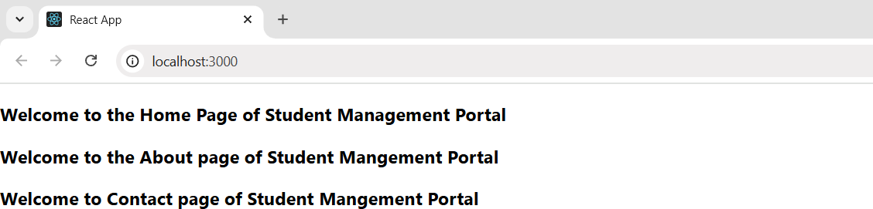

Question 3: Functional Components & Styling

Code:
import './Stylesheets/mystyle.css'
const percentToDecimal = (decimal) => { return (decimal.toFixed(2) + '%')
}

const calcScore = (total, goal) => { return percentToDecimal(total / goal)
}
export const CalculateScore = ({ Name, School, total, goal }) => (
<div className='formalstyle'>
<h1><font color="Brown">Student Details : </font></h1>
<div className='Name'>
<b> <span>Name : </span></b>
<span>{Name}</span>
</div>
<div className='School'>
<b><span>School : </span></b>
<span>{School}</span>
</div>
<div className='Total'>
<b><span>Total : </span></b>
<span>{total}</span>
<span>Marks</span>
</div>
<div className='Score'>
<b>Score : </b>
<span>{calcScore(total, goal)}</span>
</div>
</div>)

Output:

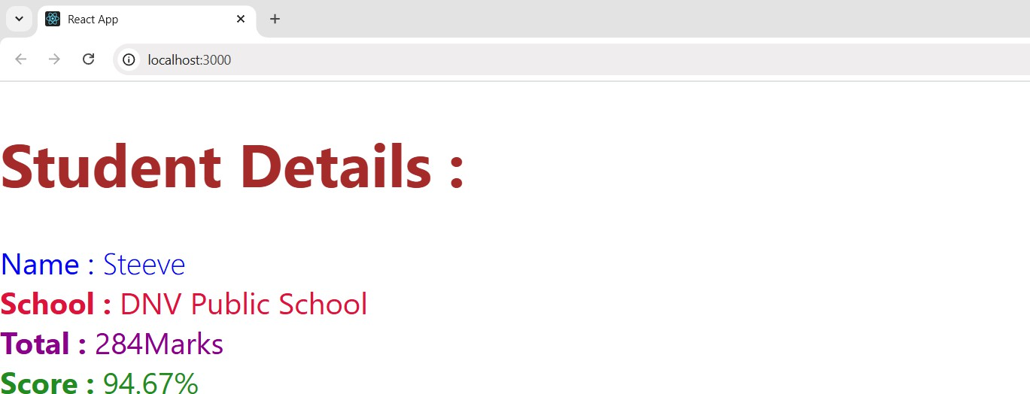

Question 4: React Component Lifecycle Methods

Code:
import Post from "./Post"; import React from "react";
class Posts extends React.Component { constructor(props) {
super(props); this.state = { posts: []
};
}
loadPosts() { fetch('https://jsonplaceholder.typicode.com/posts')
.then((response) => response.json())
.then((data) => {
const obj = data.map(value => new Post(value.id, value.title, value.body)); this.setState({ posts: obj });
})
.catch((error) => {
console.error("Error in Fetching : ", error);
});
}
componentDidMount() { this.loadPosts();
}
render() {
const { posts } = this.state;

return (
<>
<ul>
{posts.map(post => (
<li key={post.id}>
<h1>{post.title}</h1>
<p>{post.body}</p>
</li>
))
}
</ul>
</>
);
}
componentDidCatch(error, info) { console.error("Error in Posts Component: ", error);
}

}
export default Posts;

Output:

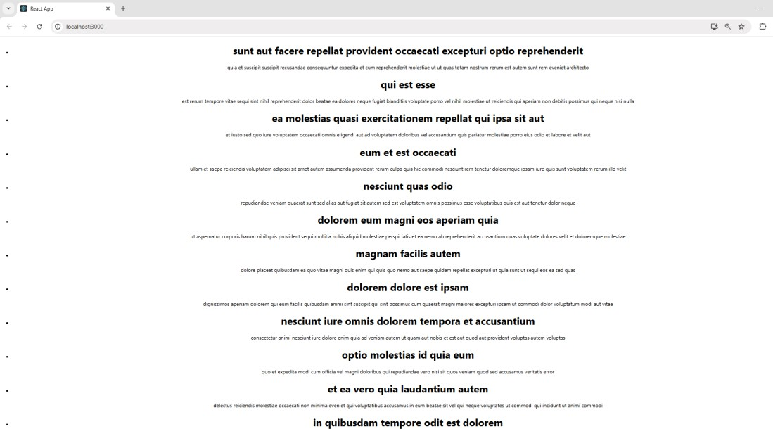

Question 5: Styling React Components with CSS Modules

Code:

//App.js
import logo from './logo.svg'; import './App.css';
import { CohortsData} from './Cohort' import CohortDetails from './CohortDetails';
function App() { return (
<div>
<h1>Cohorts Details</h1>
{CohortsData.map(cohort => <CohortDetails cohort={cohort}/>)}
</div>
);
}
export default App;

//Cohort.js
class Cohort { constructor(cohortCode,
startDate, technology, trainerName, coachName, currentStatus) {
this.cohortCode = cohortCode; this.coachName = coachName; this.trainerName = trainerName; this.technology = technology; this.startDate = startDate; this.currentStatus = currentStatus;
}
}
const CohortsData = [
new Cohort('INTADMDF10', '22-Feb-2022', '.NET FSD', 'Jojo Jose', 'Aathma', 'Scheduled'), new Cohort('ADM21JF014', '10-Sep-2021', 'Java FSD', 'Elisa Smith', 'Apoorv', 'Ongoing'), new Cohort('CDBJF21025', '24-Dec-2021', 'Java FSD', 'John Doe', 'Aathma', 'Ongoing'),
new Cohort('INTADMJF12', '22-Feb-2022', 'Java FSD', 'To Be Assigned', 'Ibrahim', 'Scheduled'),

new Cohort('CDE22JF011', '24-Dec-2021', 'Java FSD', 'Emma Swan', 'Apoorv', 'Ongoing'),
new Cohort('INTADMDF09', '22-Feb-2022', 'Dataware Housing', 'Babjee Rao', 'Aathma', 'Scheduled'), new Cohort('ADM22DF001', '10-Sep-2021', '.NET FSD', 'Marie Curie', 'Ibrahim', 'Ongoing'),
];
export { Cohort, CohortsData };

Output:
